ServiceNow Retail Service Management PoC
Technical Design Document

Version Number: V2.0
Document Details
Document Title | ServiceNow Retail Service Management PoC – Technical Design Document
Status / Version | V2.0

Criteria | Name & Role | Date
Authors | Leila Dantas, Lars Andre, Thomas Mook
Approved

Version Control
Version | Date | Description of Changes | Author
2.0 | 13.03.2026 | Add the Compose email adaptation and Notifications related to SLA | Leila Dantas,  Thomas Mook

Referenced Documents & Material
No. | Document Title | Version | Location
1 | JIRA Project incl. User Stories & Tests | N/A

Contents
1 Retail Service Management 5
1.1 Purpose 5
1.2 Overview 5
1.3 Functional Diagram 6
2 Technical Details 6
2.1 Plugins 6
2.2 Roles 7
2.3 Groups and Roles 8
2.4 System Properties 8
2.5 Dictionary Entries Overrides 9
2.6 Data Model 10
2.6.1 Retail Organization 10
2.6.2 Members and Responsibilities 13
2.7 Case Types 13
2.7.1 Service Definitions (Case Type Selection) 14
2.8 Install Base Items 15
2.8.1 Initial Load (fix scripts) 16
2.8.2 Synchronization 17
2.9 Record Producers 18
2.9.1 Retail Application Issue 18
2.9.2 Retail Network Issue 19
2.10 Case as an Incident 19
2.10.1 Case Lifecycle & State Alignment 19
2.10.2 Incident Creation from Case 21
2.10.3 Case Creation from Incident 22
2.10.4 Case updates from incident 23
2.10.5 Incident updates from case 23
2.10.6 Handling attachments 24
2.10.7 Service Operations Workspace 25
2.10.8 Business Location 360 27

3 Portal Customization 29
3.1 AI Search 30
3.2 Widgets configuration/customizations 30
3.2.1 Role-Specific KPI Layout 32
3.2.2 Removal of Task-Related Components 32
3.2.3 Case List Adjustments 33
3.2.4 Retail Organization Details Page Enhancements 33
3.2.5 Navigation Enhancement – Aspen Portal Button 34
3.2.6 Preventing Incidents from Appearing to End Users 34
3.2.7 Customization of the Ticket Action Widget 35
3.2.8 New Behavior Implemented 35
4 Notifications 36
4.1 Modification of Notification Conditions 36
4.2 RSM Notifications 37
4.3 Templates and Layouts 39
5 Surveys 39
6 Access Control Lists (ACL) 40
7 Service Level Agreement (SLA) 40

Retail Service Management

Purpose
This document provides technical guidance for configuring and managing Retail Service Management (RSM) within the adidas Aspen ServiceNow instance. It covers the retail data model, key processes, and designed configurations required to support the efficient creation, tracking, and resolution of Retail Cases.
The objective is to introduce a streamlined case‑management process for retail stores, while keeping the underlying resolution process unchanged by continuing to leverage Incidents. All store‑reported issues will be logged as Retail Cases, which are then automatically converted into Incidents for resolution. Both records remain synchronized throughout their lifecycle.
Store members will receive status updates based on the Case record, and any input or updates captured on the Case will be reflected on the corresponding Incident—and vice versa. This approach improves operational visibility, enhances the user experience for store staff, and ensures efficient and consistent handling of store‑related IT issues.

Overview
The new configuration introduces a retail‑specific data model designed to represent stores, their members, assigned responsibilities, and the corresponding install base for each location. It also includes retail cases and dedicated case types, which will serve as the central interaction record for store staff and management. Through these case types, users will be able to log store‑related IT issues in the system via the following channels:
- Record Producers in the Retail Portal (for store managers and associates)
  - Once the case is submitted, the system will automatically create an incident linked to the case. Agents will work on the incident record, while the case remains visible for tracking and reporting purposes. Synchronization between case and incident ensures that updates, comments and attachments remain consistent across both records.
- A Phone Call
  - Service Desk will create an incident, which will trigger the creation of a case, which will then be visible to Store Employees.
- Additionally, certain Monitoring Events will lead to an incident creation, which will trigger a case creation then becoming visible to Store Employees via the Retail Portal.

Functional Diagram
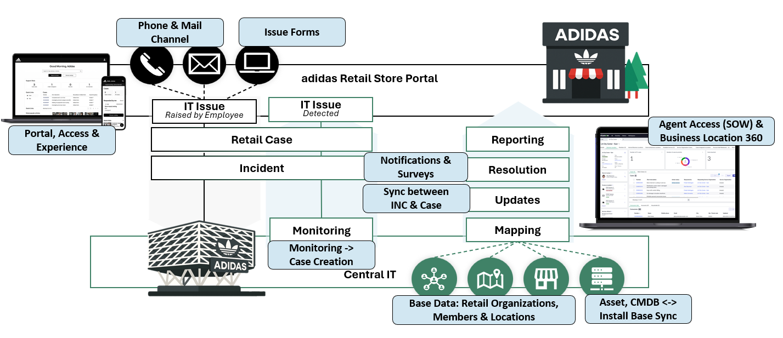

Technical Details

Plugins
Plugin Name | Plugin ID | Description
Retail Core | com.sn_retail | The ServiceNow® Retail Core application streamlines the operations of retail organizations with optimized processes and tools.
Customer Service Install Base Management | com.snc.install_base | Enables customers to capture the current state of their install base and establish the relationship to any downstream entities that might impact their functioning.
Customer Service | com.sn_customerservice | Activates the core Customer Service Management (CSM) features in ServiceNow, enabling accounts, contacts, cases, entitlements, and product-based support.
Business Location |  | Enables support for managing customer service across physical business locations such as stores, branches, franchises, and dealerships.
Customer Service with Service Management | com.sn_cs_sm | Extends core CSM with additional capabilities for structured service models and service processes.

Roles
OOTB roles installed and in use
Name | Description | Contains roles
sn_retail.associate_contributor | - Create / Review / Comment on retail cases as a contributor for their location.  - Can also resolve and reopen cases.  - Consumes a Business Stakeholder license | - sn_customerservice.service_organization_contributor  - sn_retail.case_creator  - sn_retail.org_viewer
sn_retail.manager_contributor | - Create / Review / Monitor all retail cases for the location and its hierarchy where the user is associated as contributor manager.  - Can also resolve and reopen cases.  - Consumes a Business Stakeholder license | - sn_customerservice.svc_location_manager_contributor  - sn_retail.associate_contributor  - sn_retail.report_viewer
sn_retail.support_agent | - Create / Update / Resolve retail cases irrespective of service organization.  - Tracks and fulfils retail cases at system level.  - Can Access Cases and Retail Organizations in Service Operations Workspace, and Business Location 360  - Consumes a Retail Service Management Fulfiller license | - sn_customerservice_agent  - sn_retail.case_creator​  - sn_retail.org_viewer​  - sn_retail.report_viewer
Admin | - Configure Retail Organizations  - Add members and assign responsibilities to Retail Organization

OOTB roles installed, not in use
Name | Description | Contains roles
sn_retail.associate_fulfiller | - Create / Update / Resolve retail cases associated to service organization where they are a fulfiller. | - sn_customerservice.svc_location_agent  - sn_retail.case_creator  - sn_retail.org_viewer
sn_retail.manager_fulfiller | - Create / Update / Resolve retail cases for the location as a fulfilling manager at. | - sn_customerservice.svc_location_manager  - sn_retail.associate_fulfiller  - sn_retail.report_viewer

Groups and Roles
Name | Description | Contains roles
adidas_rsm_store_associate | Store Associates | sn_retail.associate_contributor  business_stakeholder
adidas_rsm_store_manager | Store Managers | sn_retail.manager_contributor  business_stakeholder
Retail Agents | RSM Agent Roles to provide case access | sn_retail.support_agent

System Properties
Name | Application | Description | Story
sn_retail.adidas.rsm.network_business_service | Retail Core | sys_id of business service for retail network issues cases (Connectivity Services) | US-27
sn_retail.adidas.rsm.network_service_offering | Retail Core | sys_id of service offering for retail network issues cases (Connectivity – Retail) | US-27
sn_retail.adidas.rsm.application_business_service | Retail Core | sys_id of business service for application issue (Sales – Retail) | US-59
sn_retail.adidas.rsm.business_services | Retail Core | sys_id of business services that are included in the PoC scope: Sales – Retail and Connectivity Services | US-37
sn_retail.adidas.rsm.exclude_service_offerings | Retail Core | sys_id of service offering that must be excluded of PoC scope | US-37
sn_retail.adidas.rsm.locations | Retail Core | sys_id of locations that are included in the PoC scope | US-37
sn_retail.survey.assigment.group.product.name | Global | sys_id of assignment groups product names for creating survey
sn_retail.survey.customer.satisfaction | Global | sys_id of Customer Satisfaction Survey - Incident
sn_retail.survey.support.experience | Global | sys_id of Support Experience Survey
sn_retail.adidas.rsm.hardware_service_offering | Retail Core | sys_id of service offering “Hardware Support”

Dictionary Entries Overrides
No new dictionary entries were created; configuration relies on dictionary overrides for case types. Previously tracked custom fields (Ticket Type, Opened by group) were not replicated from Incident.
Column name | Type | Table
Number | Override read only | Sn_retail_application_issue
Number | Override read only | Sn_retail_network_issue
State | Override default – 10 (Open) | Sn_retail_application_issue
State | Override default – 10 (Open) | Sn_retail_network_issue

Data Model

Retail Organization
A Retail Organization in ServiceNow’s Retail Core provides the foundational structure for representing retail stores and defining how they are hierarchically connected. The platform uses a location-aware, hierarchical data model that mirrors both the operational chain of command and the physical store network. This hierarchy serves a purpose far beyond administrative grouping—it governs case visibility, access control, routing logic, and organizational reporting across all retail service processes.
      - Table structure
The following (out-of-the-box) table structure has been leveraged to model the five retail stores included in the POC and can be used for further extensions beyond the POC scope:
- Creating a Retail Organization automatically creates an associated Service Organization (Type: Internal Business Location).
- The Retail Organization and the Internal Business Location records are connected through a reference field on the Retail Organization.
- A reference to the Store Location (cmn_location table / u_retail_stores) is established on the Internal Business Location level.

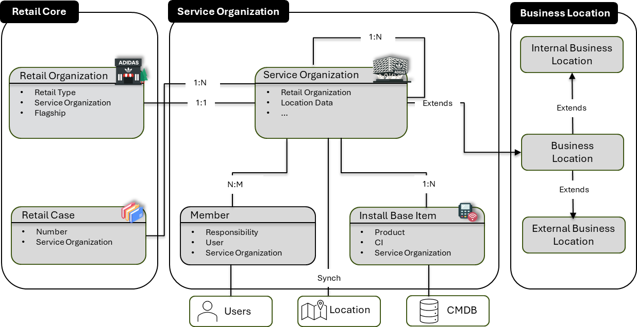

Hierarchy
There are four different elements available to model the store network’s hierarchy:
- Region (Business Group)
- Division (Business Group)
- Area (Business Group)
- District (Business Group)
- Store (Business Location).
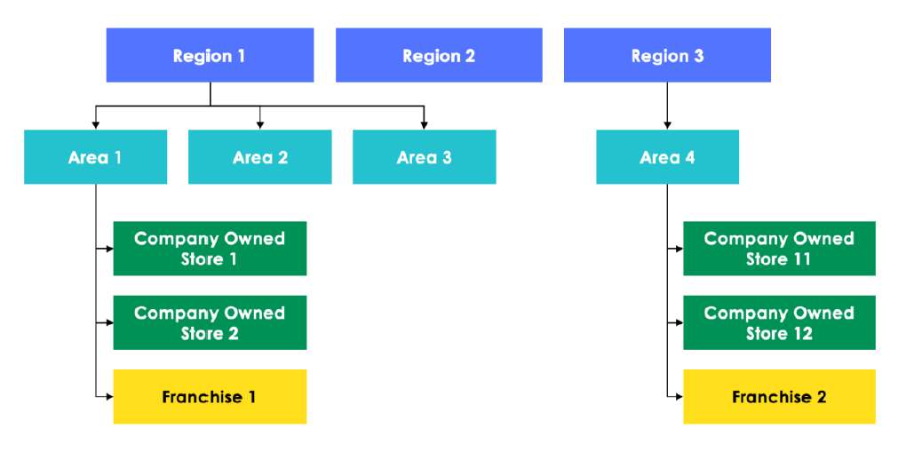
The actual hierarchy (parent-child relationship) between those four business group subtypes is flexible and to be defined on the project’s initial state. The relationship chosen for the POC (and as shown below) is: Area > District > Region > Store.
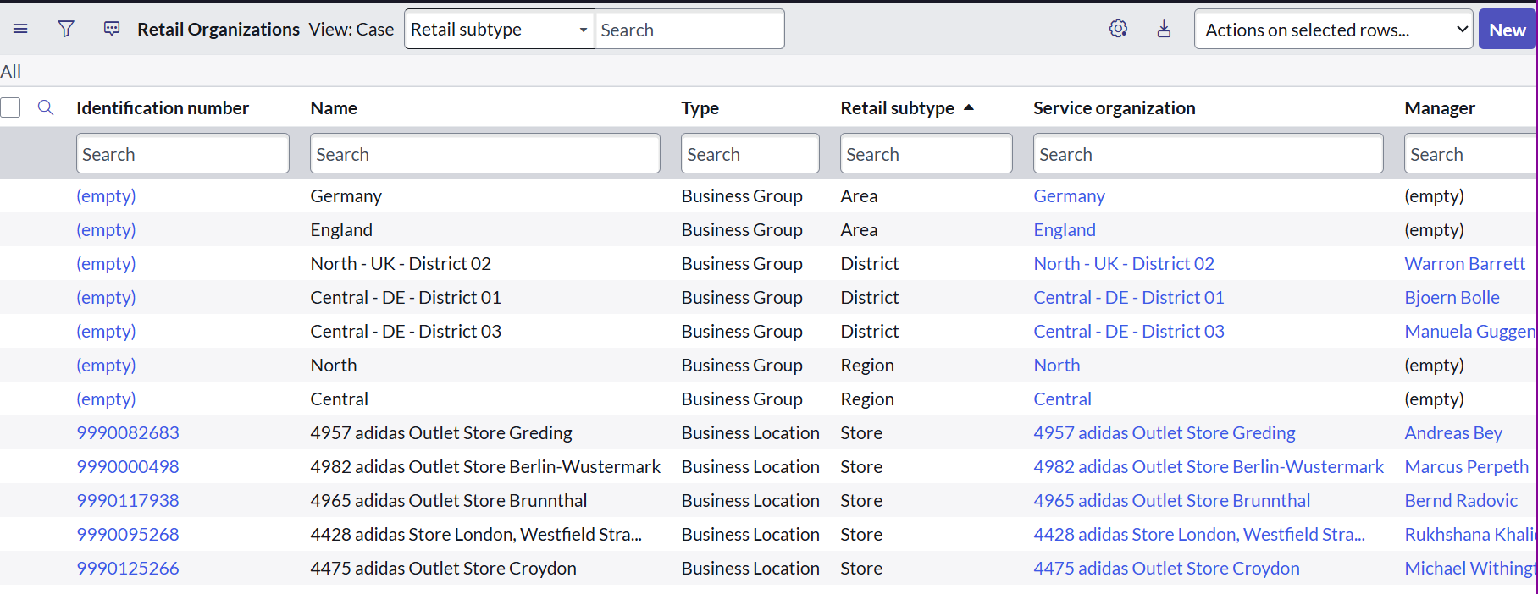

This structure is aligned with the capabilities of the Business Location and Business Organization framework included with Retail Core. It supports multi-layered organizations by providing:
- Clear accountability structure (e.g., district managers can see all stores in their district)
- Role-scoped data access, allowing contributors and managers to interact only with cases belonging to their assigned organizational tier
- Operational visibility across levels, via dashboards, KPIs, and the Business Location 360 experience
- Unified modeling for both company-owned and franchise stores, enabling consistent governance in mixed retail environments
This hierarchical model is also leveraged for case routing, notification targeting, and reporting roll-ups, ensuring that service events (e.g., issues in a store) are linked to the right location and oversight group.
To have a correct linkage to the physical stores, the field mapping of the Service Organizations was based on existing Locations (u_retail_stores):
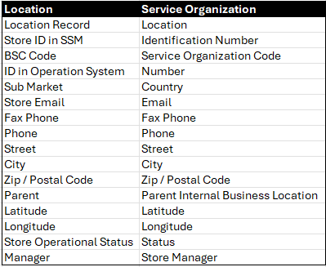
NOTE: When creating new Service Organizations, ServiceNow automatically creates a new location record (cmn_location). To meet business requirements, the location field in the Internal Business Location record was replaced with the custom location record from u_retail_store to correctly link to physical stores.

Members and Responsibilities
Each Retail Organization (Region, Area, District, Store) uses a “Related Party Responsibility” [sn_customerservice_related_party_configuration] model to express which persona is responsible for what within that organizational node.
Responsibilities describe the functional role the user performs inside the retail hierarchy. These responsibilities are stored as Related Parties linked to a Business Location or Retail Organization and represent who is accountable for the store’s operational tasks and issue handling.
- District Manager — Area Manager/Regional Manager
- Store Manager — Store Manager
- Store Associate — Store Associate

Case Types
Case types are needed when an organization has different processes for supporting customers (or in the Retail context: stores) across multiple use cases, departments, business units, or products. Case types help to separate these processes through separate applications to support each process.
Starting with the Zurich release, ServiceNow introduced a major architectural shift in how Retail Core handles cases: The Retail Case table (sn_retail_case) became an abstract base table. This means it cannot store records directly and is intended only to provide shared logic, such as common fields, business rules, UI policies, flows, and ACLs that apply to all retail case types.
This model follows the broader platform strategy of a Case Type–driven architecture, now considered the ServiceNow best practice for future-proof data models. Instead of putting logic directly into the base case table, specialized child tables (“case types”) extend the abstract parent, keeping the architecture modular, maintainable, and upgrade-friendly.
As from Zurich onwards, Case Types will become mandatory in a Retail Case context, and four “out-of-the-box” Case Types will be made available:
- Store inquiry case
- Customer complaint case
- HQ communications case
- In-store operations case
The POC environment was at the time of development still on the previous Yokohama release. In order to have a future-proof data model we already used a Case Type-driven architecture to also facilitate a later upgrade to the mandatory Case Type architecture coming with Zurich. Two case types have been defined:
- Retail Application Issue (sn_retail_application_issue)
- Retail Network Issue (sn_retail_network_issue)
These case types serve as the primary intake records for store issues and structurally separate different problem domains (application vs. network). This enables more accurate routing, analytics, and process / UI tailoring per category.
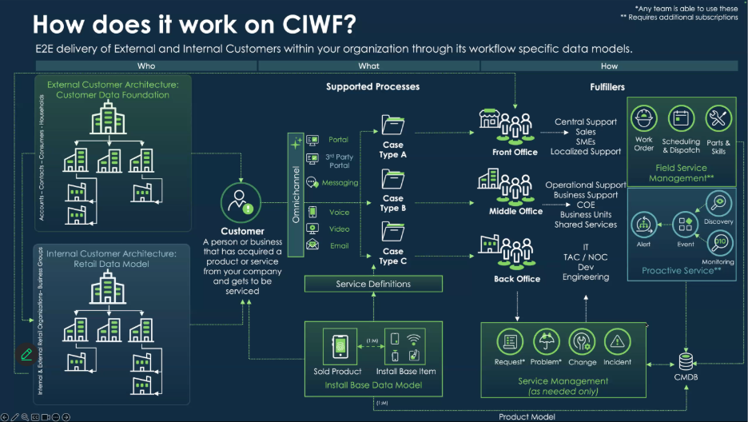

Service Definitions (Case Type Selection)
Service definitions describe the services an organization provides and link them to the appropriate case types. They streamline how service requests are created and handled by connecting products, services, and case types. Their availability can be limited to specific stores (service organizations) and store members can use these definitions to quickly discover and request the services they need.
For this POC, each case type includes a corresponding service definition (sn_case_type_selection). This allows the case type (via the connected record producer) to be exposed contextually in the Retail Portal to all eligible stores (e.g., Store Application Support, Store Network Support).

Install Base Items
ServiceNow provides a structured product data model that helps organizations track what products a store “owns”, where those products are installed, and how service processes should support them.
- Product models: A product is a type of good or service that your company sells/owns and supports. Product models identify different types of products, such as service, hardware, software, or consumables.
- Sold products: The products and components that have been “sold” or made available at a store.
- Install base items: Individual items that represent the instances that have been installed or provisioned for a store.
- Installed products: Provide information on the sold products and how they are deployed or installed. Installed products create an association between sold products and install base items.
How they work together:
Store “buys”/gets allocated to à Sold Product
- 5 Zebra Handheld Scanners Model ZQ4
Store installs à Install Base Items
- Each device becomes an IBI linked to:
  - Store location
  - CI record
Store logs issue à Case
- Store members can select the defective scanner (IBI) associated to their location
- When Case converts into Incident the linked CI will automatically be associated

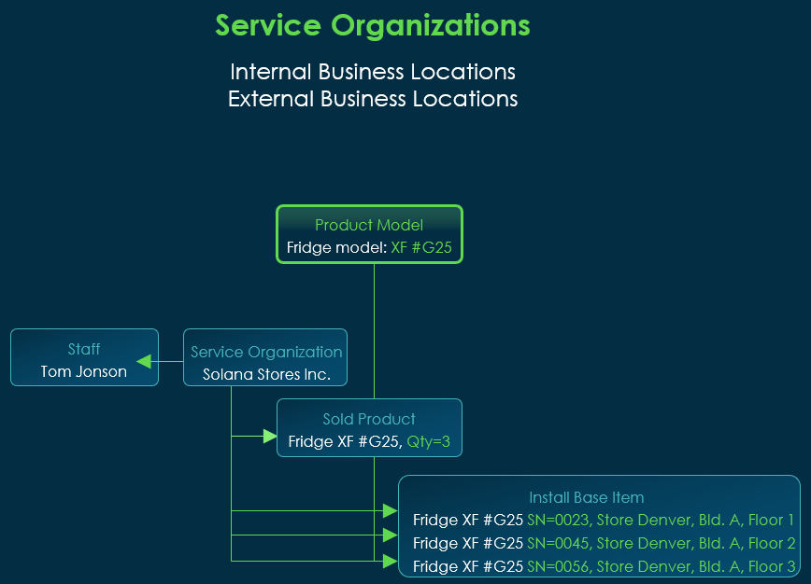
For the POC, two main sources to create Install Base Items were defined: Assets and CIs. Each were identified through specific characteristics. The created Install Base Items were associated with Product Models as well as Service Organizations and locations. A synchronization logic has been established to keep the Install Base Item database updated, when the leading record (asset or CI) changes in state and / or location.
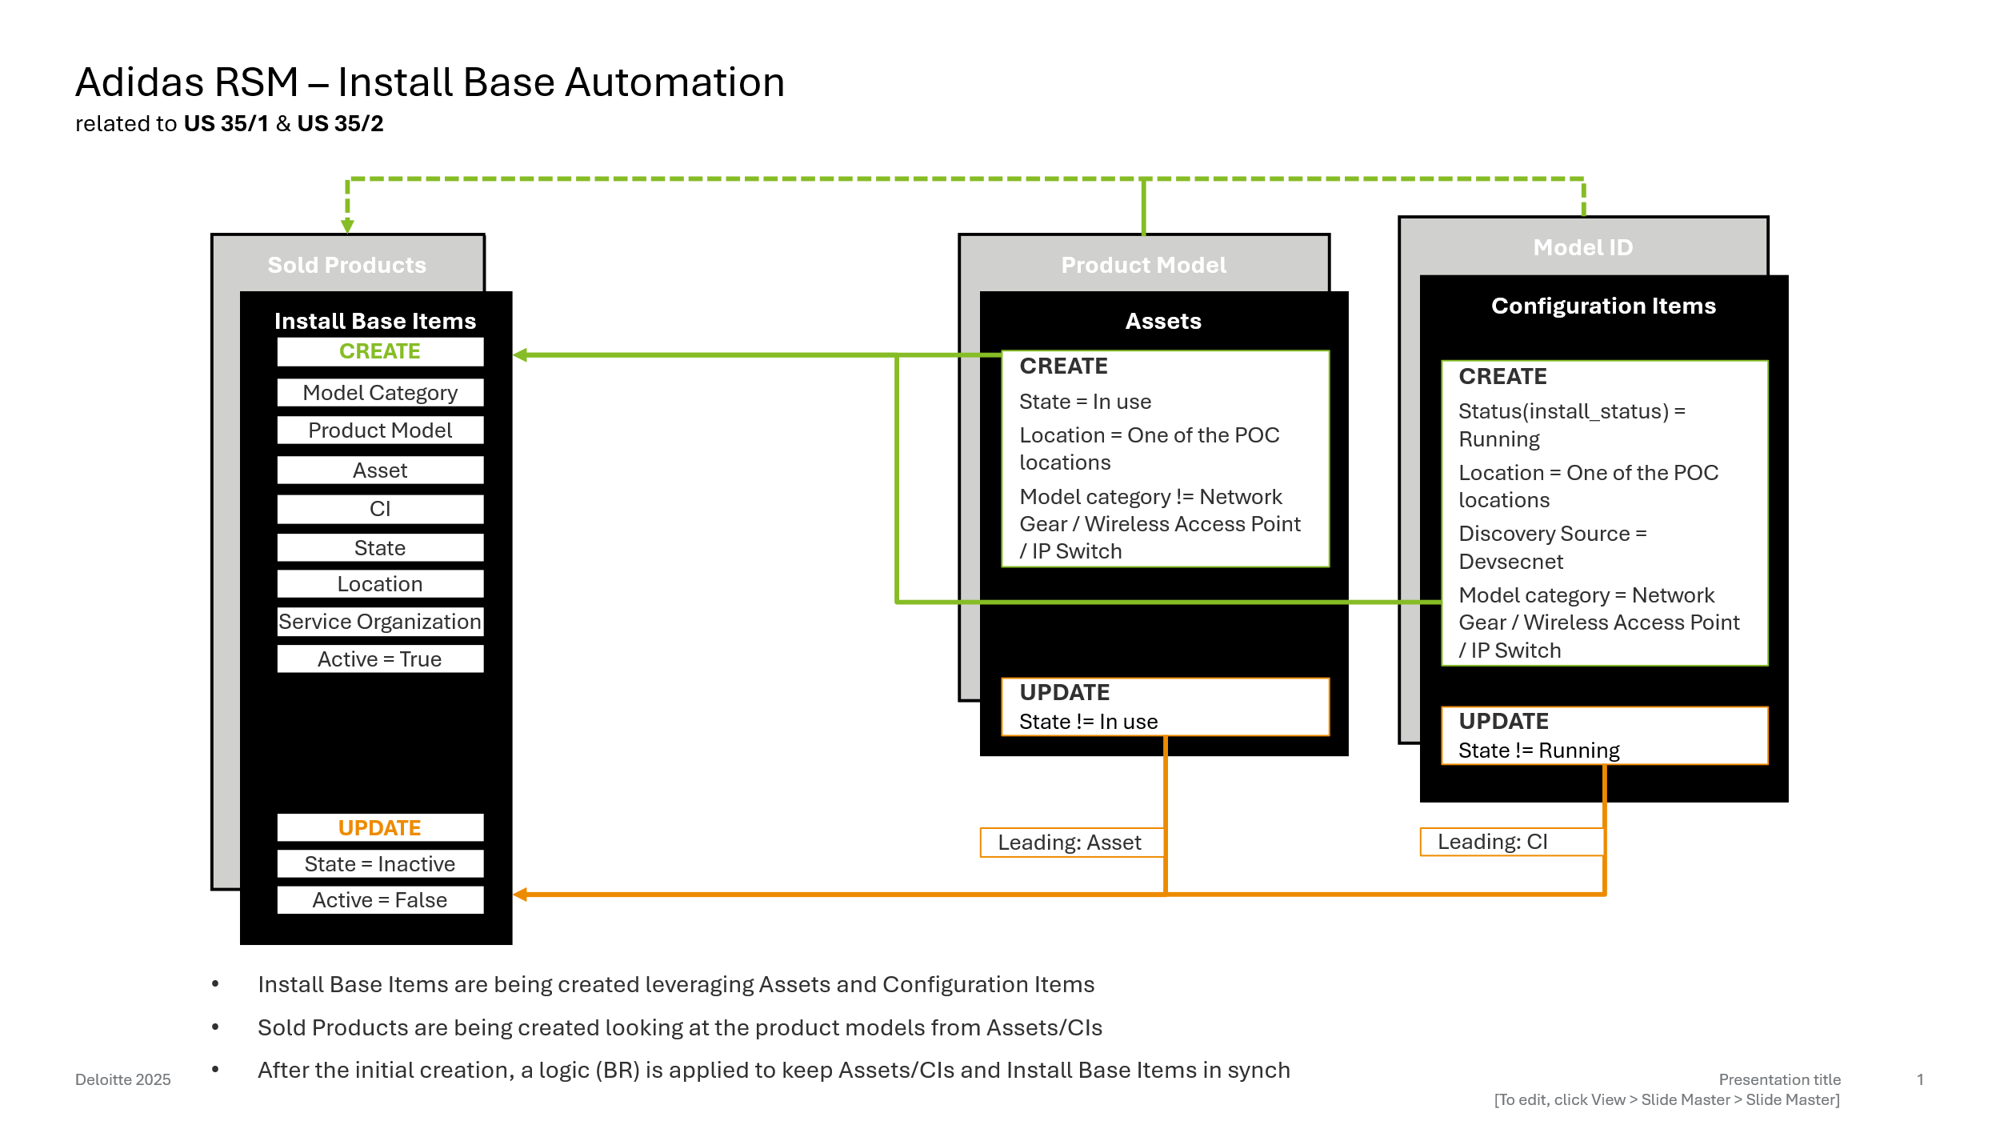

Initial Load (fix scripts)
A fix script created the initial batch of Install Base Items: One item for each Asset or Configuration Item that matched the business filter.
Configuration Item rules: Install status = Running; Discovery Source = Devsecnet; Location within PoC scope.
Asset rules: State = In Use; Model Category not in {Network Gear, Wireless Access Point, IP Switch}; Location within PoC scope.
Fix Scripts:
Name | Application | Story
Create Install Base Items - CI | Customer Service Install Base Management | US-35/1
Create Install Base Items - Assets | Customer Service Install Base Management | US-35/1

Synchronization
For future inserts, new Install Base Items are created automatically for qualifying Assets/CIs. Updates to State, Location, Discovery Source, or Model Category keep Assets/CIs synchronized with their Install Base Item.
Business Rules:
Name | When | Table | Application | Story
RSM - Update Install Base from CI | after | cmdb_ci | Customer Service Install Base Management | US-35/2
RSM - Update Install Base from Asset | after | alm_asset | Customer Service Install Base Management | US-35/2
RSM - Create Install Base from CI | after | cmdb_ci | Customer Service Install Base Management | US-35/1
RSM - Create Install Base from Asset | after | alm_asset | Customer Service Install Base Management | US-35/1

Script Include:
Name | API Name | Accessible From | Application | Story
InstallBaseSync | sn_install_base.InstallBaseSync | All application scopes | Customer Service Install Base Management | US-35/2

Record Producers

Retail Application Issue
Story | Name | Description | Table | Application
US-58 | Application or Hardware Issue | This record producer is used by store contributors to create retail application issue cases via Retail Service Portal. | Retail Application Issue (sn_retail_application_issue) | Retail Core

Decision Table – Store Application Issue
Name: RSM – Application or Hardware Issue – Global
Application: Global
Accessible from: All Application Scopes
Inputs:
- Application (Choice)
- Hardware Model Category (List)
- Functionalities (String)
Results:
- Model Subcategory (Choice – Reference existing choice list – Model Subcategory)
- Model Subcategory (Choice – Reference existing choice list – Model Subcategory)
- Service Offering (Reference – Service Offering)
This record producer provides the possibility to raise Application or Hardware issues.
For Application Issues, the following applies: This Decision Table is responsible for filtering the install base items that should be available for selection in the Retail Application Issue process. Based on the selected Application and the affected Functionality, the filtering logic uses the Model Category (up to two categories) to determine which devices are relevant.
After the filtering, the user can select the affected devices. The table also provides filtering for the Service Offering related to the selected devices, ensuring the record producer can automatically populate the corresponding case fields.
Additionally, the filtering respects the location selected on the form, so only devices associated with that location are returned.
A multiple select possibility was established when choosing the affected devices with only the first install base item selected being associated to the respective field on the case. The remaining selected devices will be documented within the case’s description field.
For Hardware, however, there is a small difference:
If the user selects the Hardware option, a Model Category can be chosen. Based on this selection and the entered Location, all install base items from the Location and the Asset Model Category will be available for selection. Regardless of which hardware issue is raised, the Service Offering will always be “Hardware Support”; this was defined via a system property.
NOTE: To create a consistency dependency between the functionalities and the application, it was inserted a choice list for “u_functionality_retail” with empty table and dependent value being the application related to.

Retail Network Issue
The network form serves as a step-by-step guide to assist users in diagnosing and resolving issues. If the problem persists after completing all steps, the user has the option to submit a case.

Story | Name | Description | Table | Application
US-27 | Network Issue | This record producer is used by store contributors to create retail network issue cases via Retail Service Portal | Retail Network Issue (sn_retail_network_issue) | Retail Core

NOTE: When a store user submits a Record Producer to create a Retail Case, the variable responses recorded in the question_answer table must also be visible to fulfillers on the linked Incident within the Variables section. To support this requirement, the solution duplicates the Case’s question_answer records and reassigns them to the newly created Incident at the moment of incident generation, ensuring the same variable values are displayed consistently on both records

Case as an Incident

Case Lifecycle & State Alignment
In the adidas RSM solution, Case and Incident function as two intentionally separate record types, each serving a distinct audience and purpose:
- Retail Case → Store-facing record (Store Associate, Store Manager, District Manager)
- Incident → Fulfiller-facing record (IT support, service desk, resolver groups)
This separation was explicitly required by the business:
Store users must continue using Cases as their simplified, retail-friendly interface, while fulfillers must continue working exclusively on the Incident within the Service Operations workspace. The Incident remains the authoritative record for investigation, triage, SLAs, routing, and resolution.
To support this hybrid model, both lifecycles need to remain synchronized, even though the two records are used by different personas.

Why Alignment Is Required:
CSM ↔ ITSM Integration Best Practice
ServiceNow recommends using Cases as the customer-facing object and Incidents as the IT fulfillment object, with controlled synchronization between them. This ensures a clean separation of responsibilities while maintaining a cohesive service experience.
Business Requirement: Fulfillers Must Work on Incidents only
The adidas Retail Operations business mandated that:
- IT teams must continue using Incident forms, states, work notes and SOW tooling.
- Store users must only see simplified Case states and Additional Comments, not Incident complexity.
- All updates visible to the store must originate from the Incident but appear in the Case.
State Mapping
The following mapping was implemented to meet both ServiceNow architectural constraints and business requirements:
Incident Value | Incident Display | Case Value | Case Display
1 | Assigned | 10 | Open
3 | In Process | 2 | Work in Progress
4 | Awaiting Customer | 18 | Awaiting Info
7 | Closed | 3 | Closed
5 | Pending | -5 | Pending
6 | Solved | 6 | Resolved

Incident Creation from Case
In the adidas RSM model, every Retail Case automatically creates a linked Incident. This integration pattern was explicitly chosen to meet the business requirement.
The following mapping ensures all necessary information flows from the Case into the Incident so fulfillers can begin work immediately, without requiring store users to enter IT-centric data.
Incident form | Retail Case OOTB
*User | Internal User / Opened by
*Business service | Business Service
*Service offering | Service Offering
Configuration item | Configuration item
*Impact | Impact
*Urgency | Urgency
Priority | Priority
Created | Created
Opened by | Opened by
State | State
*Assignment group | Assignment group
Assigned to | Assigned to
Location | Requesting Service Organization.Location
*Short Description | Short description
*Description | Description

Business Rules:
Name | When | Table | Application | Story
RSM - Create Incident From Case | after | sn_retail_case | Service Management Integrations | US-24
Sync case worknotes after inc state chg – OOTB - deactivated | after | Incident | Service Management Integrations | US-24
Check for Req SO or SO – OOTB – Customized | NOTE: OOTB validation rule that originally blocked updates when Retail Organization fields were missing.  This solution adds a guard condition for new records, ensuring the Case→Incident creation process does not fail during initial inserts.

Script Include:
Name | API Name | Accessible From | Application | Story
CSMIncidentIntegrations | sn_cs_sm.CSMIncidentIntegrations | This Application Scope Only | Service Management Integrations | US-24

NOTE: To override the Read Only Script Include that was responsible for copying the fields from case to incident, we have edited the Extension Point as below:
- Open the Extension Point:
https://adidasaspendev.service-now.com/nav_to.do?uri=sys_extension_point.do?sys_id=5e0aa43187b313003c1c8467a7cb0b0f
- Override the Method as per requirement.
- Click the "Create Implementation" Related Link
- See a New Script Include is created which will override the Out of Box functionality.

Case Creation from Incident
Incidents that qualify as Retail Incidents automatically create a linked Retail Case.
Qualification rules:
Business Service is either Connectivity Services or Sales – Retail
Location is within the PoC scope
Service Offering is not any of: WFM Scheduling; WFM Employee Data – Automation; WFM Administration; WFM Time-Evaluation; WFM Employee Data; WFM Absence-Management; WFM Reporting; WFM Timekeeping – Automation; WFM Timekeeping

Business Rule
Name | When | Table | Application | Story
RSM - Create case from incident | after | incident | Retail Core | US-26

Script Include:
Name | API Name | Accessible From | Application | Story
RetailFilters | sn_retail.RetailFilters | All Application Scopes | Retail Core | US-26, US-58
CaseIncSync | sn_retail.CaseIncSync | All Application Scopes | Retail Core | US-26, US-58
NOTE: The RetailFilters Script Include provides helper methods used to determine whether an Incident qualifies as a Retail Incident before a case is automatically created from it. It evaluates key attributes such as location, business service, and service offering against configured system properties. Based on this logic, the script identifies incidents that fall under the retail scope and should follow the Retail Case creation process. The script is also responsible for filters applied to the “Application or Hardware Issue” record producer.

Case updates from incident
Whenever changes are made in the Incident record, the corresponding field values must be reflected in the related Case. This applies especially to state changes, comments, and any information store users must see. For every update, the RetailFilters Script Include determines whether the incident is a retail incident. Due to changes in the Business Service or Service Offering, there may be situations where the connection between the case and the incident is lost, as there is no reference field available on the Incident form. Therefore, a fallback scenario exists: A query checks whether an incident has a related case available. This logic applies to all incidents where the Location field is populated.
Name | When | Table | Application | Story
RSM - Synchronize state changes - INC | after | incident | Service Management Integrations | US-26
RSM - Sync case with incident updates | Before | Incident | Service Management Integrations | US-26
Sync case worknotes after inc state chg – OOTB - Deactivated | After | Incident | Service Management Integrations | US-26
Update case worknote for comments change – OOTB - Deactivated | Before | Incident | Service Management Integrations | US-26

Incident updates from case
Since fulfillment agents work primarily on the Incident, Case-originated updates are limited. Only additional comments and state transitions triggered by store users (resolve/reopen actions) are synchronized back to the Incident. This ensures that store-driven actions do not break the fulfillment workflow while keeping both records aligned.
Business rules:
Name | When | Table | Application | Story
RSM - Sync case closure | Async | sn_retail_case | Service Management Integrations | US-26
RSM - Update Case Comments | Async | sys_journal_field | Service Management Integrations | US-38/US-39
NOTE: The business rule “RSM - Update Case Comments” manages bidirectional comment synchronization. A stamping mechanism is used to mark synchronized comments, preventing infinite update loops.

Handling attachments
As part of the integration requirements, all information stored in Cases must be propagated to their corresponding Incidents and vice-versa.
This includes not only field values and variables, but also file attachments.
However, copying attachments in both directions introduces a risk of infinite loops (e.g., an attachment copied from Case → Incident being copied back from Incident → Case, repeatedly). To prevent this, additional logic and a controlled execution mechanism were created.
Business Rules:
Name | When | Table | Application | Story
RSM - Copy attachment to incident | Async | sys_journal_field | Service Management Integrations | US-26
RSM - Copy attachment to case | Async | sys_journal_field | Service Management Integrations | US-26

Subflow Used to Prevent Loops
To safely handle this bi-directional synchronization, a dedicated Flow Designer subflow was created. This flow is always executed as system, and it writes a special metadata property indicating that the attachment was system-created.
This allows the platform to distinguish between:
User-added attachments → should be copied
Automatically copied attachments (system) → should not trigger another sync
This mechanism eliminates the risk of recursive copying between Case and Incident.
Subflows:
Name | Run as | Accessible From | Application | Story
Copy attachments from incident to retail case | System | All Application Scopes | Service Management Integrations | US-26
Copy attachments retail case to incident | System | All Application Scopes | Service Management Integrations | US-26

Service Operations Workspace

Forms and Views
Because fulfillment activities will take place only at the incident level, and not at the case level, the business required that the Service Operations Workspace (SOW) be used as the primary workspace for handling Retail-related Incident fulfillment. As a result, the Customer Service Management (CSM) workspace will not be used or updated for this purpose.
To support this approach, several adaptations were implemented in the Service Operations Workspace.
Additions to Default SOW List Configuration
Three new lists were added to the Default – SOW list configuration and are visible to fulfiller agents (sn_retail.support_agent):
- Category (sys_ux_list_category):
  - Retail Service Management
- Lists (sys_ux_list):
  - Retail Service Organizations
  - Network Issue Cases
  - Application Issue Cases
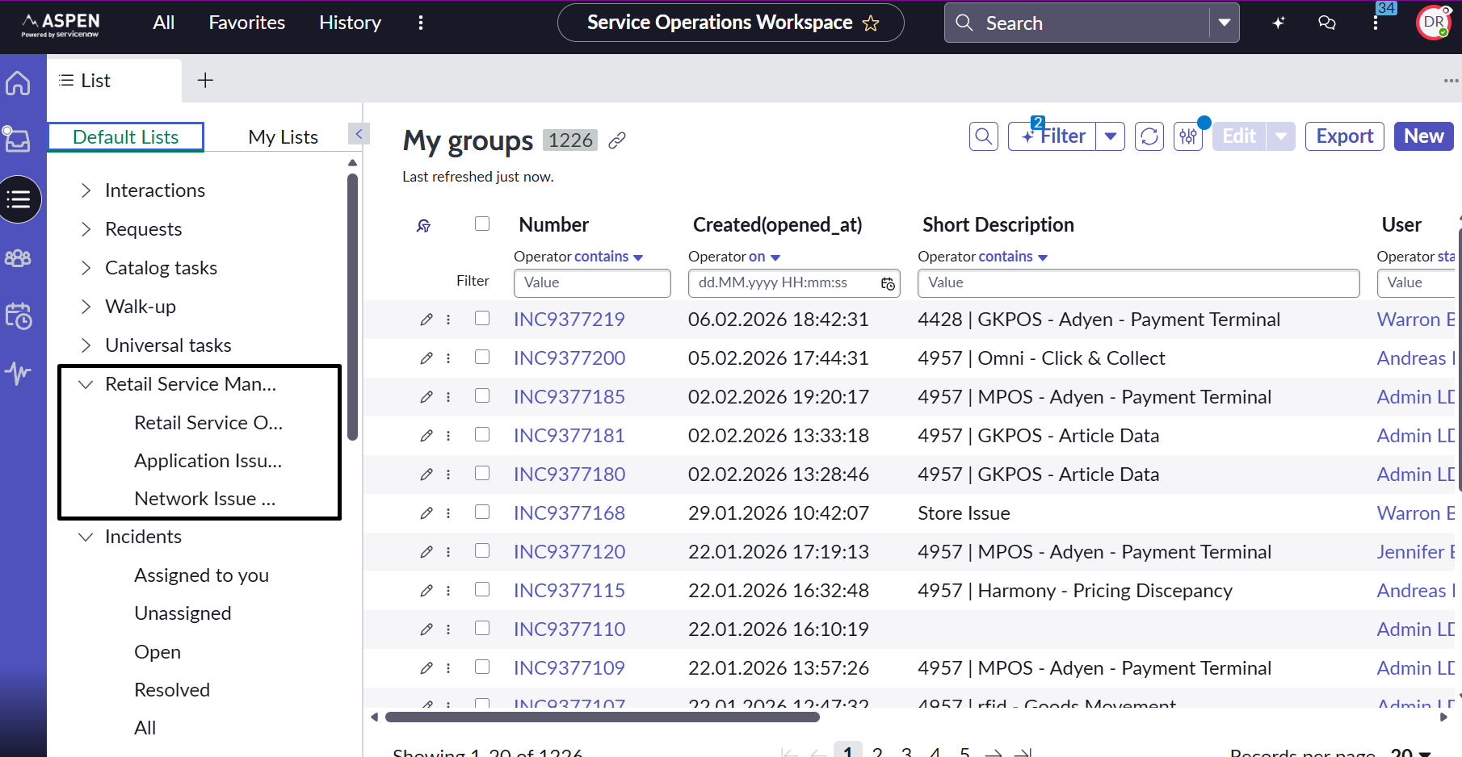
These additions support easier access to Retail-specific records and improve navigation for service desk agents.

New Workspace View for Case Types
A new workspace view was created for the case-type forms. This view improves navigation across related forms (Case → Incident) and consolidates all business-required fields in a single, more streamlined interface.
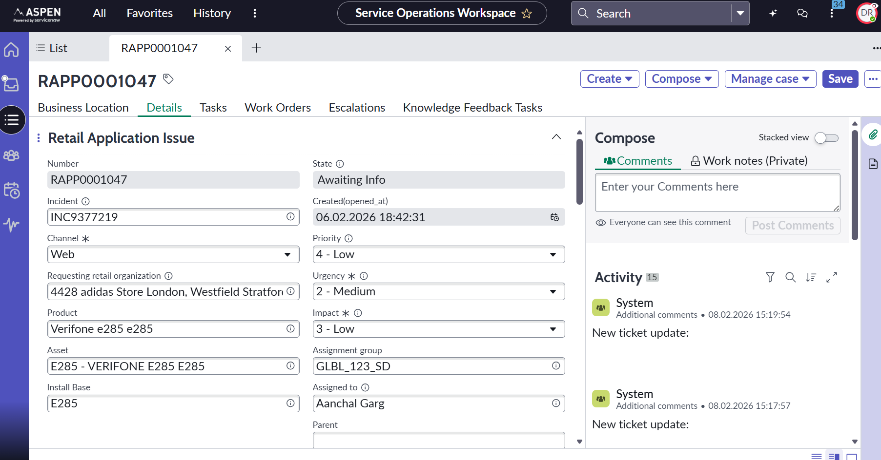

Enhancements to the Incident View
The Incident form was updated to include a related list displaying Customer Cases.
This enables service desk agents to easily access the case associated with the incident, ensuring smoother navigation and more efficient case-to-incident traceability.
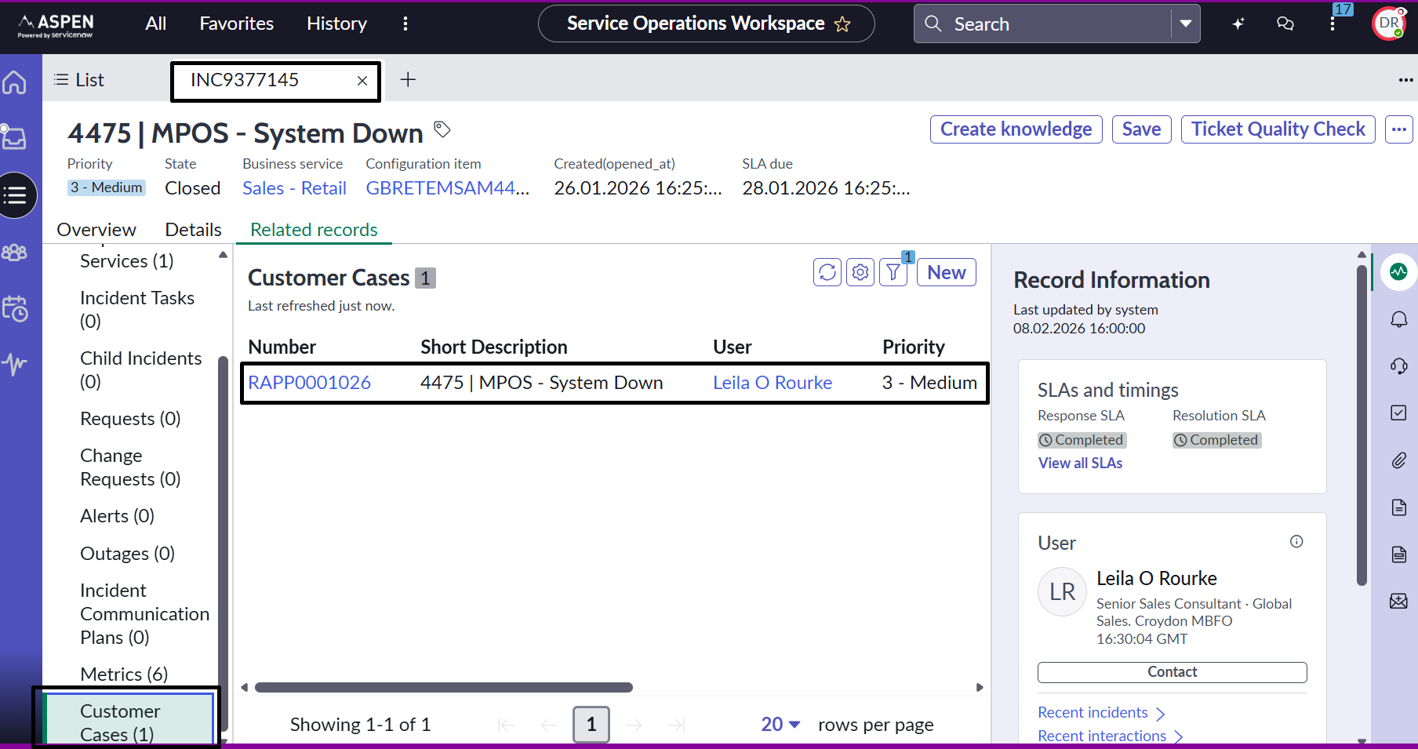

Business Location 360
The Business Location 360 page provides a consolidated view of operational data related to Retail Organizations and related case activity. Although this feature is originally designed for the CSM/FSM Configurable Workspace, the business required that service desk agents working in the Service Operations Workspace (SOW) also have access to this overview.
To enable this functionality in SOW, we extended the workspace configuration so that the Business Location 360 page becomes available when agents open Retail Case Types or Retail Organization records. The extension ensures that agents using SOW have the same location-level visibility as those working in CSM, without modifying or impacting the original out-of-the-box behavior.

Adjustments for the Retail Workflow
Because the Retail fulfiller workflow differs from standard CSM usage, several adjustments were made to the version of Business Location 360 that appears inside SOW:
- The widget referencing Consumers and Accounts was removed, as these entities are not part of the Retail execution model.
- The SLA Breached Cases widget was replaced by the Awaiting Info widget, providing better visibility into records waiting for updates.
- The order of widgets was reorganized to match the prioritization and navigation flow defined by the Retail team.
These adjustments ensure that the information displayed is relevant, actionable, and aligned with the fulfiller’s operational needs.
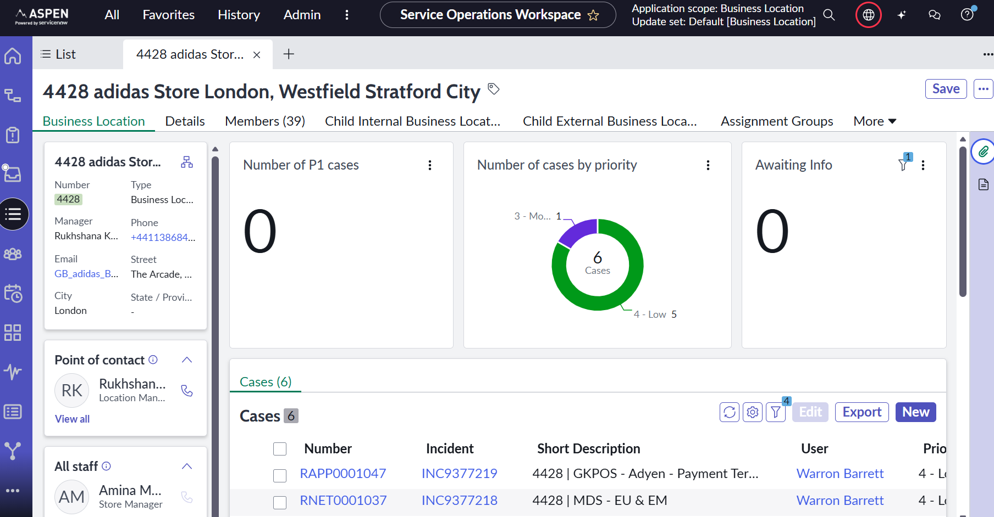

Enabling the Page Inside the Workspace
To make Business Location 360 available within the Service Operations Workspace (SOW), we implemented the feature in three layers:
- Record Registration in the Workspace
  - We first added a new record entry under the workspace’s Records configuration.
  - This record entry is scoped to Retail records (Retail Case Types and Retail Organizations).
  - It uses the existing “Case Record” template that ships with workspaces, preserving parity with the standard Case experience.
- Business Location 360 Rendering
  - Within the record experience, the rendering is driven by multiple page collections.
  - In the page collection responsible for Business Location 360—namely “CSM Default Record Pro Details”—we:
    - Duplicated the Business Location 360 page inside the same page collection (we did not edit or replace the OOTB page).
    - Applied filters so this page appears only for Retail Case Types and Retail Organizations.
    - Assigned a lower order (higher priority) than the OOTB page to ensure the Retail-specific page is selected when relevant, while the standard OOTB page continues to serve all other use cases.
- Including Supporting Pages
  - Business Location 360 relies on dependencies that must also be available in the workspace for the page to render correctly.
For this reason, the following supporting pages were added to the workspace, using the original OOTB versions:
    - Business Location Hierarchy
    - Business Location Members
  - These two pages were introduced exactly as they exist OOTB—no modifications were applied. They are included purely to satisfy dependency and navigation requirements inside the 360 experience.
Important: No out-of-the-box (OOB/OOTB) pages, templates, or medium-risk files were modified. All changes were additive and isolated to new configuration artifacts.

Upgrade and Maintenance Considerations
- OOTB assets remain intact: We did not modify the original Business Location 360 page or any OOTB page collections/templates. This reduces merge conflicts during upgrades.
- Introduces limited technical debt: Duplicating a page inside an OOTB page collection is an additive pattern, but it does create some technical debt:
  - If ServiceNow enhances the OOTB Business Location 360 in a future release, those improvements will not automatically carry over to the duplicated Retail page.
  - Adidas will need to periodically compare the OOTB page to the custom Retail page and manually reconcile changes where necessary.
- Potential upgrade impacts: Although we avoided editing medium-risk files, ordering logic and filter conditions may require verification after upgrades:
  - Validate that the order precedence still selects the Retail page for applicable records.
  - Reconfirm that record filters continue to target the intended case types and Retail organizations.
- Persona isolation maintained: The customization is scoped to Retail and does not affect other personas or workspaces that rely on the default Business Location 360.

Portal Customization
To ensure brand consistency and meet the business’s UI/UX expectations, several portal components were cloned and customized.
Cloned Theme: “RSM – EC Theme”
The existing RSM – EC Theme was cloned to serve as the styling foundation for the Retail Portal.
- Achieve UI/UX consistency with the adidas Aspen branding.
- Allow modifications without touching OOTB Employee Center theme assets.
Customizations Included
- Additional CSS files injected into the theme
- Modifications to the page structure, spacing, and layout
- Updates to typography, color variables, and component appearance to align with adidas branding guidelines
Cloned Header: “RSM Header”
- The standard Employee Center header was cloned to create a Retail-specific header.
Customizations Applied
- Removed “My Tasks” and “My Requests” to avoid exposing workflows, tickets, or actions store users should not access
- Adjusted CSS variables to adjust the adidas logo on the header
- Removed navigation elements irrelevant to store personas
- Ensured the header remains compatible with the RSM Theme and the Retail Portal page structure

AI Search
AI Search Enablement
AI Search was explicitly enabled for the RSP to provide:
- Better ranking, relevance, and result aggregation.
- Unified result sets (catalog, knowledge, cases, content).
- More intelligent suggestions for store users.
Creation of the RSP Default Search Application (Custom)
A new Search Application was created from scratch specifically for the Retail Portal.
Employee Center’s prebuilt search applications cannot be reused without exposing data or modules irrelevant to stores.
The RSP required a restricted, retail-scoped search configuration.
The Search Application defines:
- Which sources are searchable (Cases, Knowledge, Catalog Items)
- How results are grouped and displayed
- Access restrictions based on retail personas
- Custom phrasing, prompts, and UX for the retail context
Search Results Configuration (Custom)
A Retail-specific Search Results configuration was also created from scratch to complement the RSP Search Application.
Search Profile (Custom)
A dedicated RSP Search Profile was created. This profile is responsible for defining:
- What the store user can and cannot see in search
- Filter rules for each content source
- Priority ordering of search sources
The Search Profile acts as the authorization & filtering layer for RSP search.

Widgets configuration/customizations
Knowledge Base
Because there was no retail-specific KB defined for the PoC, the AskIT knowledge base was added as the searchable knowledge source within the Retail Portal.
Portal Configuration (Retail Portal and Employee Center)
To meet the Retail business requirements, several adjustments were made to the Retail Portal and limited changes were introduced in the Employee Center.
KPI Widget Customization (Role-Based Configuration)
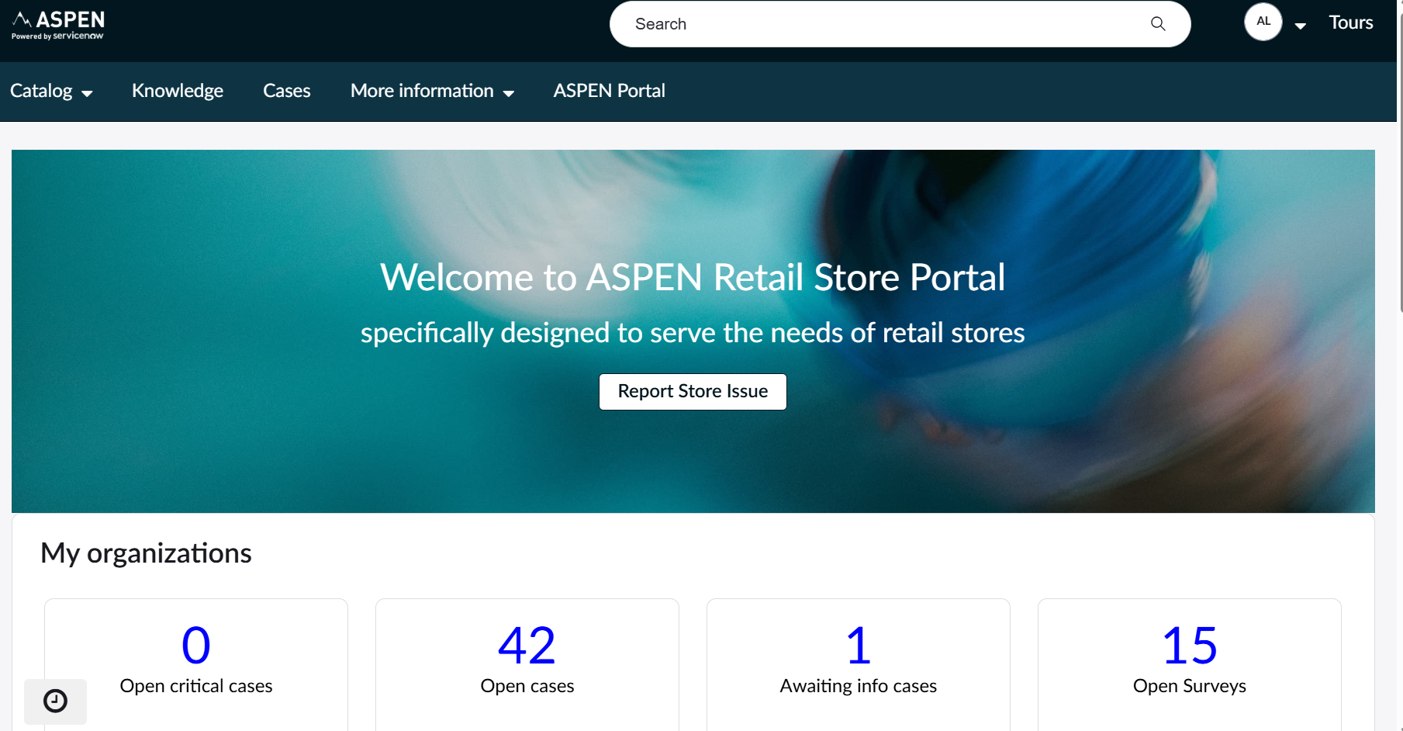
As part of the Retail Portal configuration, the standard KPI Widget was copied and customized to implement the role-specific requirements defined by the business.
The OOTB widget was not modified; instead, a new widget instance was created to ensure upgrade safety.
All SLA-related metrics were removed, and the definitions of “Open Cases” and “Open P1 Cases” were updated to reflect the business interpretation that “open” means any case not in Resolved or Closed states.
In addition, the widget was tailored for each Retail persona, ensuring that each role sees only the KPIs relevant to their responsibilities.

Role-Specific KPI Layout
Below is the configuration implemented for each persona:
District Manager / Area Manager / Regional Manager
- Action Needed – Open P1 Cases
- Action Needed – Open Cases
- Action Needed – Awaiting Info Cases
Store Manager – Contributor
- Action Needed – Open P1 Cases
- Action Needed – Open Cases
- Action Needed – Awaiting Info Cases
- Requested by Me
Store Associate – Contributor
- Action Needed – Open Cases
- Action Needed – Awaiting Info Cases
- Requested by Me
All Users
- Action Needed – Open P1 Cases
- My Assigned Cases
- Requested by Me
- Escalated Cases

Removal of Task-Related Components
Because Retail collaborators do not work on tasks, all task-related components were removed from the portal experience:
- OOTB task widgets were removed from the home page.
- Task lists were removed from case details.
- Task references were removed from the Retail Organization Details page.
This cleanup ensures the portal displays only the information that is relevant to Retail operations and avoids confusing users with unused functionality.
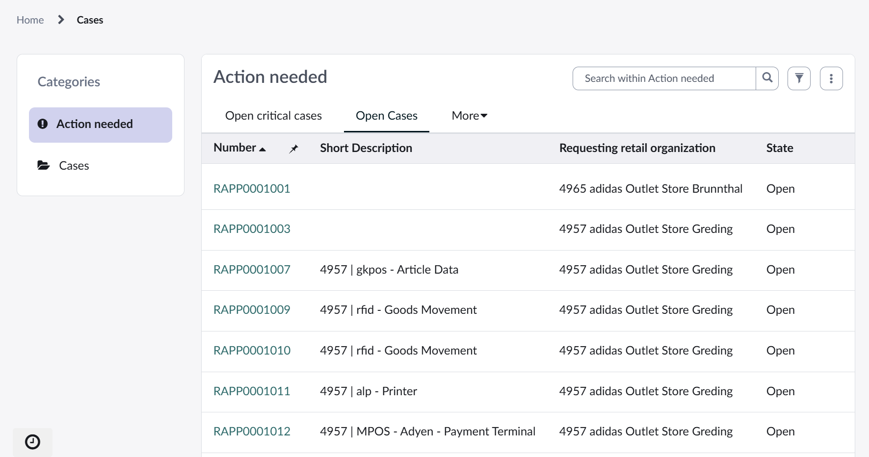

Case List Adjustments
To ensure consistency between the KPI widget and the tables presented in the portal:
- The Case list widgets/tables were updated so that the “Open Cases” list shows the same filtered results as the updated KPI:
  - All cases not in Resolved or Closed states.
- This guarantees functional alignment between the metrics and the actual data visible to users.

Retail Organization Details Page Enhancements
To improve visibility at the organization level, the following changes were made to the Retail Organization Details page:
- Removal of Tasks
  - Task lists were removed since they are not used in the Retail fulfillment model.
- Addition of Active Install Base Items
  - A new list showing active Install Base Items associated with the Retail Organization was added.
  - The table view was optimized to display only relevant fields:
    - Configuration Item
    - Asset Tag
    - Serial Number
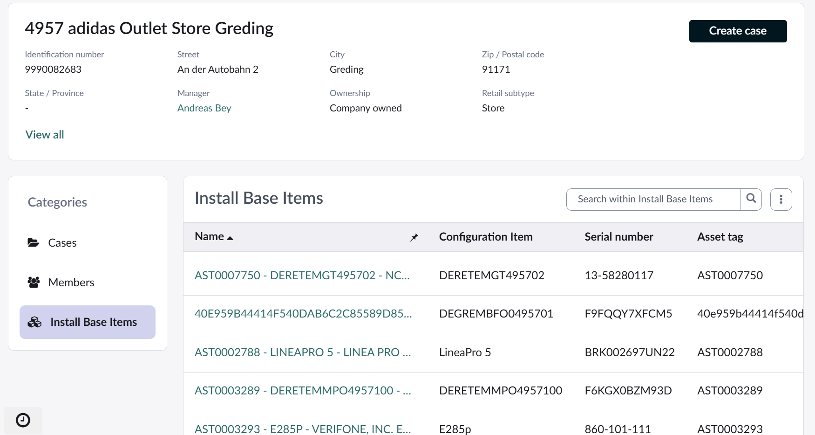

Navigation Enhancement – Aspen Portal Button
A new “Aspen Portal” button was added, allowing Retail Managers to switch easily between:
The Retail Portal (Retail Workspace/Portal)
The Employee Center
Only managers were given the ability to switch between portals:
- The “Retail Portal” and “Aspen Portal” buttons appears only for managers, allowing them to navigate from the Employee Center back to the Retail Portal.
No other user-facing components were changed on Employee Center.

Preventing Incidents from Appearing to End Users
Because Retail processes rely on Case → Incident creation (incidents being used for fulfillment), a problem arose:
- Incidents created for Retail stores were appearing in the Employee Center as if they belonged to the end user who opened the case.
- This was confusing and unintended, since end users should only see the Case, not the underlying Incident.
To correct this:
- A Before Query Business Rule was implemented on the Incident table.
- This rule prevents non-agent users from retrieving or viewing Incidents associated with Retail store operations.
As a result:
- Only agents can view or interact with Incidents.
- End users continue to see only the Case, as intended.
This ensures a clean separation between requester experience (Cases) and fulfiller experience (Incidents).
Business Rule:
Name | When | Table | Application
RSM - Filter out RSM incidents | Before Query | incident | Global

Customization of the Ticket Action Widget
The RSM Standard Ticket Action widget, provided out-of-the-box, originally displayed the following options to store users:
- Close Case
- Edit
- Assign to Me
To better match the Retail workflow and avoid confusion:
- The widget was cloned into a custom version (leaving the OOTB widget intact).
- The new widget was edited to replace the default actions with the correct state-based actions.

New Behavior Implemented
The customized widget now presents only actions relevant to Store Employees, adjusting dynamically based on the Case status:
- If the Case is not resolved:
→ Resolve
- If the Case is already resolved:
→ Reopen
This gives Store Employees a clear and intuitive way to manage the lifecycle of their own requests.
- The resolution of the Case indicates their acknowledgment that the reported issue is addressed.
- They may need to Reopen a Case if the issue persists or was not satisfactorily resolved.
- The previous OOTB options (“Close”, “Assign to Me”, “Edit”) did not reflect any of these behaviors.
The new model creates a workflow that makes sense for store staff while keeping the agent/fulfiller processes cleanly separated.
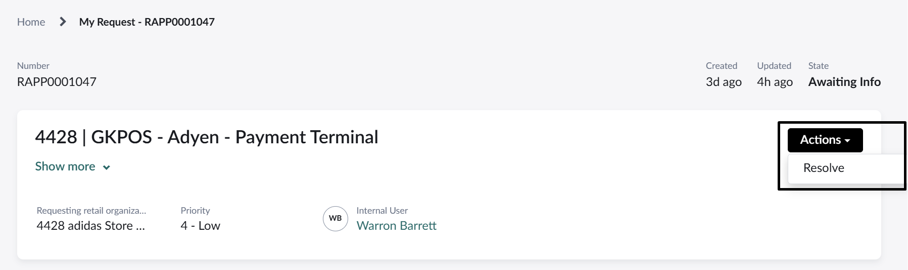

Notifications
As part of the project requirements, Incidents created from Retail Case issues must not send standard ITSM notifications to the end users who originally reported the problem.

Modification of Notification Conditions
The condition scripts of the existing Incident notifications were updated to include a new validation layer.
Each notification now checks whether the Incident originates from a Retail Case–related business context.
This determination is performed based on three key Incident fields:
- Business Service
- Service Offering
- Location
These fields allow the system to identify when an Incident represents a Retail operational issue (as opposed to a standard ITSM incident).
If the Incident matches the Retail profile, the notification is suppressed.
This ensures that store employees do not receive ITSM emails that are not relevant for their workflow.

Compose Email
The Compose Email functionality—normally used to request additional information from the user and trigger an outbound email—was also adapted for the Retail Incident flow. The feature remains active; however, the email sending action is suppressed. Instead, only the underlying logic continues to execute, ensuring that the Add Comment action and the corresponding task SLA triggers behave as expected.
This behavior is applied exclusively to Retail Incidents, specifically those that satisfy the defined criteria for Business Services, Location, and Service Offerings used to identify Retail records.

RSM Notifications
Because the default Incident notifications are suppressed, custom Case-related notifications were created to replace them:
Notifications
Scenario | Name (with URL) | Description | Recipients
New Retail Case Created | Retail Case - Ticket Created | Notification sent to the Managers when a Retail Case is inserted/created. | Location Managers, Store Managers
Retail Case Resolved | Retail Case-TicketSolutionProposed | Notification sent to the Managers when a Retail Case is resolved. | Location Managers, Store Managers
Retail Case Resolved | Retail Case-TicketSolutionProposed EUS | Notification sent to the Managers when a Retail Case is resolved. | Location Managers, Store Managers
Retail Case Updated | Retail Case - Ticket Updated | Notification sent to the Managers when a Retail Case is Updated | Location Managers, Store Managers
1st Reminder - SLA | Retail Case - 1st Feedback Reminder | Notification sent to the Managers when they need to provide information | Location Managers, Store Managers
2nd Reminder - SLA | Retail Case - 2nd Feedback Reminder | Notification sent to the Managers when they need to provide information | Location Managers, Store Managers

To support the RSM Notifications, four custom events were created:
Event | Description | Fired By
sn_retail.adidas.retail.case.creation.no | Event is fired by Business Rule which contains store managers to send notification to them | Business Rule adidas_retail_case_creation_to_managers
sn_retail.adidas.retail.case.solved.noti | Event is fired by Business Rule which contains store managers to send notification to them | Business rule adidas_retail_case_solved_to_managers
sn_retail.adidas.case.solved.notificatio | Event is fired by Business Rule which contains store managers to send notification to them | Business rule adidas_retail_case_solved_to_managers_eus
sn_retail.adidas.case.comment | Sends notification to all managers if a case has a new comment | Business Rule adidas_retail_case_comment_to_managers
sn_retail.adidas.case.sla.1 | Event is fired by Script Action which contains store managers to send notification to them | Script action RSM - 1st SLA case notification
sn_retail.adidas.case.sla.2 | Event is fired by Script Action which contains store managers to send notification to them | Script action RSM - 2nd SLA case notification

A set of business rules is responsible for firing these events at the right time and passing the correct parameters to the notifications:
Name | When | Table | Application
adidas_retail_case_comment_to_managers | After | sn_retail_case | Retail Core
adidas_retail_case_solved_to_managers | After | sn_retail_case | Retail Core
adidas_retail_case_creation_to_managers | After | sn_retail_case | Retail Core

To trigger the 1st and 2nd SLA Case notifications, the following approach was implemented:
The native event responsible for firing SLA notifications for standard Incidents (which is suppressed for Retail Incidents) still executes as usual. However, instead of sending the default SLA notification, this event triggers a Script Action.
This Script Action is then responsible for firing the custom Retail Case SLA event, which is linked to the corresponding Retail Case SLA notification.
This mechanism ensures that the SLA workflow remains aligned with the platform’s standard behavior while routing the trigger to the customized Retail Case notification events.
Script Actions:
Name | Description | Fired Event | Application
RSM - 1st SLA case notification | Script Action responsible for firing the 1st Retail Case SLA event. | adidas_incident_sla_customer_response_1 | Retail Core
RSM - 2nd SLA case notification | Script Action responsible for firing the 2nd Retail Case SLA event. | adidas_incident_sla_customer_response_2 | Retail Core

Templates and Layouts
Two templates were created to handle different communication needs during the Case lifecycle.
Template name | Used for | Description
RSM Case Template | Case Created  Case Updated | Template used for all non-resolution notifications. Displays case metadata, updates, and store-friendly information.
RSM Case Tree Layout | Case Resolved | Template used specifically when a solution is proposed. Includes resolution summary and space for decision buttons.
NOTE: Matching the templates, two layouts were created to control the visual structure and branding of the emails.
A dedicated Email Script was created to dynamically generate the action buttons embedded in the Case Resolution email: adidas_retail_case_resolved_body.

Surveys
The RSM solution required a custom survey-triggering mechanism to collect store user feedback when a Case is resolved. Because Retail Cases are fulfilled via Incidents—but store users should not receive ITSM surveys related to store issues, a dedicated survey configuration was implemented.
When a Retail Case is resolved, a Business Rule automatically creates surveys for the appropriate store users using existing survey definitions (no new surveys were created)
Business Rules:
Name | When | Table | Application
adidas_retail_case_survey | After | sn_retail_case | Global
RSM - Filter out Incident Surveys | Before (query) | asmt_assessment_instance | Global
Retail Case State changes to Closed | After | asmt_assessment_instance | Global
NOTE: To ensure that surveys generated for Retail Incidents are hidden in the Aspen portal, a Before Query business rule was implemented to filter them out.
- The rule checks the assignment group’s product (taxonomy node).
- It compares this product sys_id against a system property.
- Based on this match:
If the product is in the configured list → Support Experience Survey is used.
Otherwise → Customer Satisfaction Survey is used.
NOTE: Surveys are sent to the Store Manager (always) and to the Opened By user only if they are different from the Store Manager

Access Control Lists (ACL)
In addition to OOB ACLs, new ACLs are created, and old ones are modified to manage below accesses:
- Create a retail case from RSP Portal.
- Add comments/provide information on the retail case.
- Able to close a retail case directly from RSP portal.
ACL List:
We did not modify or deactivate any OOTB ACLs. Baseline rules remain authoritative for record, table, and field-level controls. The following three ACLs were created as additive rules:
Name | Operation | Description
sn_retail_application_issue | write | Custom ACL created for write rights in sn_retail_application_issue for Store contributors.
sn_retail_network_issue | write | Custom ACL created for write rights in sn_retail_network_issue for Store contributors.
sn_retail_case.work_notes | read | Deny read access to work notes for store employees.
Why deny read on work notes: Work notes are for fulfillers/internal stakeholders, while end-user communications should use Additional comments. Allowing end users to see work notes can unintentionally expose technical or sensitive information.

Service Level Agreement (SLA)
Specific case SLAs will not be introduced, Incident SLAs will remain in place as is. All SLA elements visible to end users (Store staff=) will be removed (e.g. KPI Widget Case).

